Linux Commands

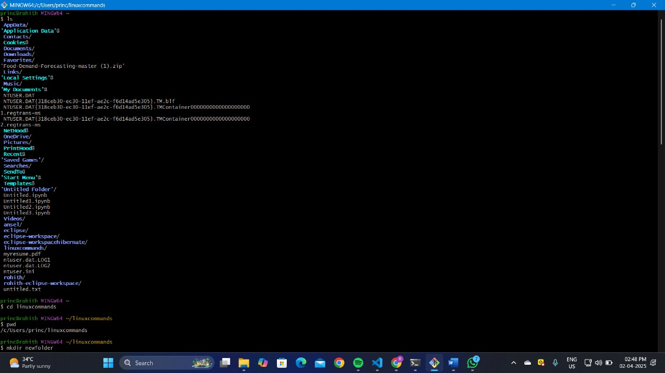

img-1

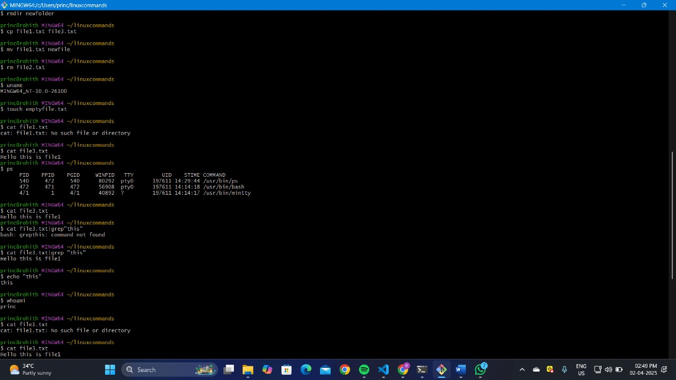

img-2

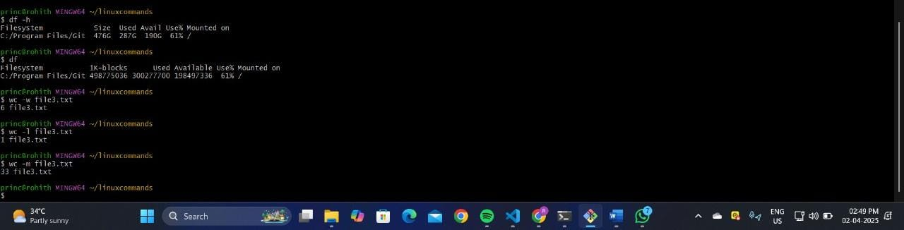

img-3

Commands in image-1

Ls -> show list of folders

Cd -> to move forward to directory

Pwd -> show path

Mkdir -> make new directory

Commands in image-2

Cp -> copy content of one file to another file

Mv -> rename the file

Rm -> remove file

Uname ->show system details

Touch -> create empty file

Cat -> to see content of the file

Ps -> to see active process

Grep -> to get string with the substring you given

Echo -> simply prints the data what you given

Whoami -> to get who is user

Sort -> sort the content in the file

Commands in img-3

Df -h -> outputs will be more understandable

Df -> similar to df -h but output in bytes which is not readable

Wc -w -> displays no. of words in a file

Wc -l -> displays no.of lines in a file

Wc -m -> displays no. of characters in a file